**How to perform MFA resets (Phone number and Authenticator App)**

* Preface: As users change phone numbers or get their phones replaced, they run into issues whenever they are prompted for MFA because the challenge was tied to their old device. This document is a explains how to clear out a user’s old phone data so that the next time they try to login, it will prompt them to go through the initial setup as if they were a brand new employee logging in for the first time.

1. Login to Microsoft Azure AD
   1. Navigate to <https://aad.portal.azure.com/#view/Microsoft_AAD_UsersAndTenants/UserManagementMenuBlade/~/AllUsers>
   2. Sign in with your usual Microsoft credentials

1. Find the users that needs to be reset. You can search by name or email address

* Click on the user that needs to be reset

* Click on “Authentication Methods” on the left-hand side

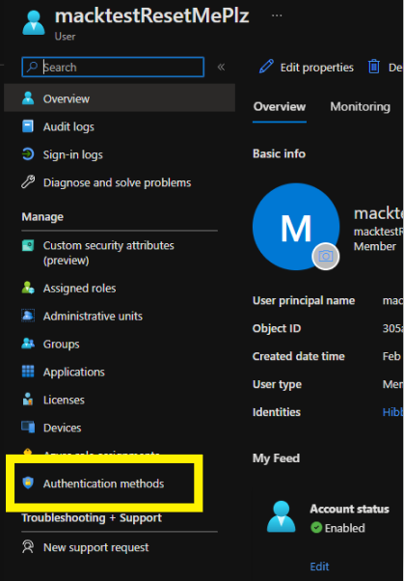

* Click on “Require re-register multifactor authentication” and then wait 2-3 minutes.
  + This will clear out ALL existing MFA methods and prompt the user to register for MFA on the next login

